Day 2
Exercise - Page 102-103 # 12, 14, 5, 21, 23, and 28
12 See back of book

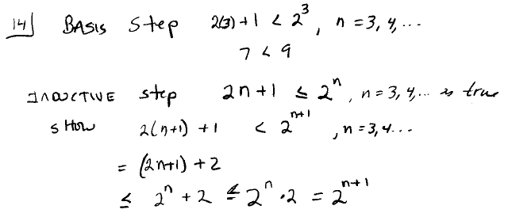

15. See back of book

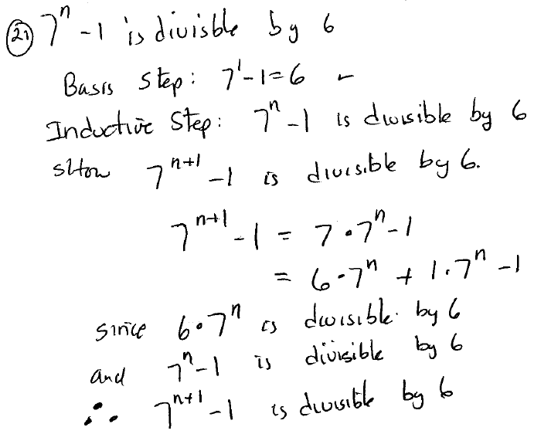

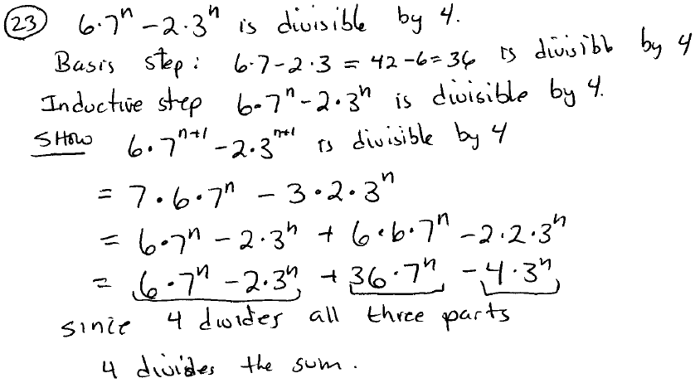

28 